OS LAB 07 Exercises

TASK1:

CODE:
#include<stdio.h>
#include <sys/types.h>
#include <unistd.h>
#include <stdlib.h>
int main(void)
{
pid_t childprocess = fork();

if (childprocess > 0){
printf("I m a parent!");
sleep(50);
}
else
{
printf("I m a child :P");
exit(0);
return 0;
}

}

Result:
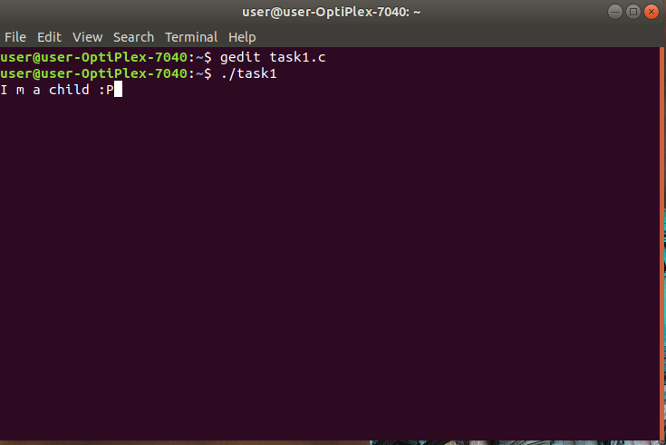

TASK2:

CODE:
#include<stdio.h>
#include <sys/types.h>
#include <unistd.h>

int main()
{
pid_t childprocess = fork();

if (childprocess > 0)
printf("I m a parent process :D \n");

else if (childprocess == 0)
{
sleep(100);
printf("I m a child process :P \n");
}

return 0;
}

Result:
